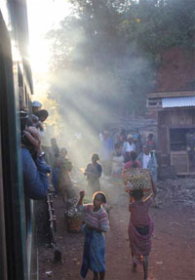 | Nieuwsbrief 1 van Facebook pagina  `De roep van de indri`  http://www.facebook.com/roep.van.indri  Interessante artikelen/websites over Madagaskar  december 2013- februari 2014
1. The lemur end-game: scientists propose ambitious plan to save the world's most imperiled mammal family
http://news.mongabay.com/2014/0220-hance-lemur-plan.html?fbfnpg
2. The Palms of Madagascar (Evening talk)
https://www.facebook.com/events/179032282299275/
3. Crisis in Madagascar: 90 Percent of Lemur Species Are Threatened with Extinction
http://blogs.scientificamerican.com/extinction-countdown/2014/02/24/crisis-madagascar-lemurs-extinction/
4. Wildlife photo’s of Madagascar van Helene Turner
https://www.facebook.com/party.zebra.jsy/media_set?set=a.10152223934589767.1073741832.598789766&type=1

5. Madagascar's new president pledges to fight illegal logging
http://news.mongabay.com/2014/0207-madagascar-rosewood-logging-fight.html#j6eqS8X1e2lMB6DB.99
6. In de Volkskrant van dinsdag 4 februari stond een artikel over de vanilleteelt in Madagaskar.
Unilever en zijn leverancier Symrise gaan een project opzetten om de vanilleteelt in Madagaskar te verduurzamen. Madagaskar is goed voor een derde van de wereldproductie van vanille.
http://www.volkskrant.nl/vk/nl/2844/Archief/archief/article/detail/3589692/2014/02/04/Madagaskars-boeren-verdienen-weinig-aan-Magnums.dhtml
7. Een YouTube video over zeereservaten in Madagaskar:
http://www.youtube.com/watch?v=gJcsvEpJlVI
8. Vanishing forests
http://www.thestar.com.my/News/Environment/2014/01/13/Vanishing-forests/
9. Wildmadagacar.org
https://www.facebook.com/wildmadagascar
10. Madagascar: British photographer Nick Garbutt's 20-year survey of the island’s wildlife
http://www.telegraph.co.uk/earth/earthpicturegalleries/8231475/Madagascar-British-photographer-Nick-Garbutts-20-year-survey-of-the-islands-wildlife.html
11. Foto’s van Sandrine over wildlife in Madagaskar 1
https://www.facebook.com/sandrine.martinez.336/media_set?set=a.10151313352921873.527744.723881872&type=3
12. Forto’s van Sandrine over wildlife Madagaskar 2
https://www.facebook.com/sandrine.martinez.336/media_set?set=a.10151040370741873.488684.723881872&type=3
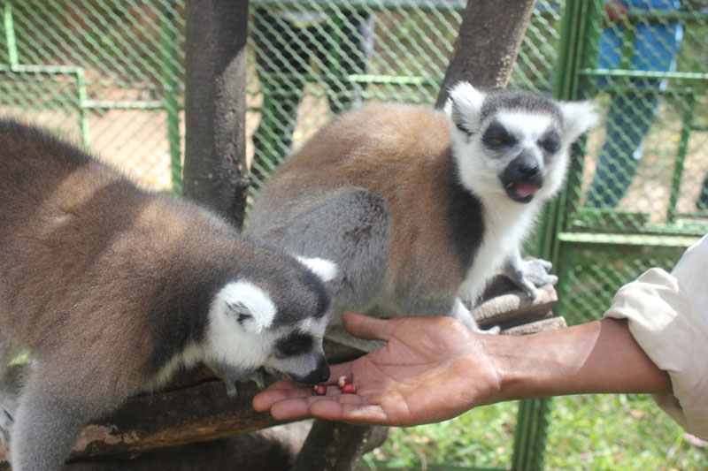

nteresting websites about Madagascar
8 september 2013 om 14:14
Reisadvies ministerie van Buitenlandse Zaken
http://www.rijksoverheid.nl/onderwerpen/reisadviezen/madagaskar
“Travel and living abroad” van het Verenigd Koninkrijk
http://www.fco.gov.uk/en/travel-and-living-abroad/travel-advice-by-country/sub-saharan-africa/madagascar
Madagascar News: News on Madagascar continually updated from thousands of sources around the net.
http://www.topix.com/world/madagascar
IRIN, humanitarian news and analysis- a service of the UN Office for the Coordination of Humanitarian Affairs
http://www.irinnews.org/Country/MG/Madagascar
The Telegraph- Madagascar News http://www.telegraph.co.uk/news/worldnews/africaandindianocean/madagascar/
All Africa.com: Madagascar
http://allafrica.com/madagascar/
Madagascar Online
http://www.madonline.com/sommaire.php
Laurent Ploch and Nicolas Cook
Madagascar’s Political Crisis
Congressional Research Service, June 18, 2012
http://www.fas.org/sgp/crs/row/R40448.pdf
Madagascar gets biggest protected area
Mongabay.com, August 17, 2012
http://news.mongabay.com/2012/0817-makira-madagascar-wcs.html#J16MVLV6TcqlaBu7.99

